**Revised 12/2023**

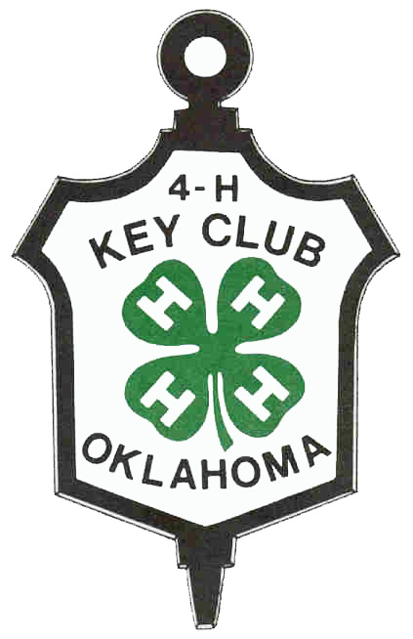

# OKLAHOMA 4-H KEY AWARD PROGRAM

Established 1950

### Oklahoma 4-H Key Club: An Explanation

Membership in the Oklahoma 4-H Key Club is an honor extended only to top 4-H members. It is an honor that you must work hard for, but upon receiving the award, you and your Cooperative Extension staff will feel pride and satisfaction for a job well done.

**History**

Since 1950, 4-H Key Club has been recognizing the accomplishments of Oklahoma youth in the 4-H Program. The club seeks to honor those 4-H members who possess leadership, loyalty, and a sense of responsibility to the total 4-H Program.

**Objectives**

The objectives of this organization are:

1. To recognize the outstanding accomplishments of Oklahoma’s very top 4-H members.

2. To provide a common bond among former 4-H members.

3. To further develop 4-H work in Oklahoma.

The program is based on standards. Individuals meeting these standards are eligible to become members. Key Club is an honor society for 4-H members who have done outstanding work in the organization. Once 4-Hers become Key Club members they accept the obligation to support the 4-H organization throughout their lives, both financially and with their time. Key Club members also strive to stay updated with Oklahoma 4-H and Oklahoma 4-H Key Club.

**Qualifications for Membership**

The applicant:

1. Must be a 4-H member. Must show an ACTIVE status in online 4-H enrollment program.

2. Must be in 9th, 10th, 11th, or 12th on September 1, on the year of application.

3. Must submit completed application form by the published state record book deadline.

4. Must accumulate the minimum number of points (400) on the application form.

5. Must be approved by the county Extension Educator.

6. Must make at least one presentation to a 4-H Group about Key Club.

7. Must make at least one presentation to a non-4-H Group, such as non-4-H youth or adults, about the

4-H youth development program.

**Awards**

Every applicant who qualifies for Key Club is eligible to receive a Key Club certificate and key.

**Membership Procedures**

1. Key Club membership is awarded only to 4-H members who qualify based on the application.

2. Each county will designate an Extension Educator or staff member to verify the information in the application and submit the names of eligible members selected from the county to the state 4-H office.

3. There is no limit on the number of applicants from a county for a given year.

4. Two keys for each county will be provided – they must be ordered on the county medal order form. Counties desiring to present more than two awards will be responsible for purchasing the additional keys from the Oklahoma 4-H Office at Oklahoma State University.

5. Applicants will become official Key Club members contingent upon the Extension Educator adding delegates name to Oklahoma 4-H Record Book Data Base by the published state record book deadline.

6. Each county Extension Educator will be responsible for:

* Distributing the application forms to the prospective members.
* Checking and approving application forms. (Forms do not get turned into State Office)
* Adding delegates name to the Oklahoma 4-H Record Book Data Base by the published state record book deadline. (Educators: delegates should be added to the Key Club Award)

### The following reports are required for membership in Oklahoma 4-H Key Club

**PART I: Presentation**

To be considered for 4-H Key Club membership, you must make two (2) 4-H presentations: one about the 4-H program and one about the Oklahoma 4-H Key Club. The presentation about the 4-H program must be to a non-4-H group; the presentation about 4-H Key Club must be to a 4-H group. PowerPoint resources are available on the Oklahoma 4-H Website to assist in making these presentations.

**PART II: Reports**

After the presentations, the 4-H member must write two separate reports, one report for each presentation. The following information must be included at the top of the page for each report:

Name of Group; Contact Person; Mailing Address; Phone Number

**Narrative:**

The narrative portion of each report must be no more than 1 page in length and must be on one side of an 8 1/2 x 11 sheet of paper, using 1-inch margins on all sides. The report must be neat and the information must be accurate and complete. Attach reports to your 4-H Key Club application. Items to be reported in each essay include:

1. Name of program

2. Date and location the program was presented

3. Number of people in attendance

4. What type of response did your program receive? Did sponsorship or awareness

of the 4-H program increase in some way because of your presentation? Do you have other observations/comments?

## Oklahoma 4-H Key Award Program

## Application Form

|  |  |  |  |  |  |
| --- | --- | --- | --- | --- | --- |
| County: |  | | | Local Club: |  |
| Name |  | | | Phone # |  |
| Complete Mailing Address | | | | Name of Parents or Guardian: | |
|  | | | |  | |
| Grade in School: | |
| Number of Years in 4-H: | | |  | Total Number of Points earned: | |
| Birthdate: (00/00/0000) | |  | |

All items are optional, but a total of 400 points must be earned for membership.

**Points are accumulated based on your total years of work in 4-H.**

| **Activity** | **Number** | **Points per activity** | **Maximum points** | **Points Earned** |
| --- | --- | --- | --- | --- |
| 1. Submitted a Project Record Book to county for State Competition   Number of years you entered a State Record Book |  | 10 | 50 |  |
| 1. Submitted a county project report form to county office   Number of years you entered a county report form or county record book. |  | 5 | 30 |  |
| 1. Held a 4-H office, such as President, Vice-President, Secretary, Song Leader, Recreation Leader, Reporter, etc. at the local or county level or served as a state 4-H Ambassador.   Include all offices for all years.  local office  county office  district office  state office  state ambassador | # of years | 5  5  10  10  10 | 20  20  20  20  20 |  |
| 1. Gave original 4-H Presentation before a regularly scheduled meeting to a Civic Group (such as Lions, Kiwanis, HCE, Business & Professional Women, Farm Bureau, American Farmers and Ranchers, PTA, or other non-4-H group) on the local or county level **At least one presentation and follow up report is required for award.**   List group, name and contact person and date of presentation |  | 25 | 50 |  |
| 1. Gave a presentation on 4-H Key Club to a 4-H Club. List the name of the club, leader’s name, and date presented. **Include report. This is required to become a Key Club Member.** |  | 25 | 25 |  |
| 1. Gave an original presentation before a 4-H group other than your own local club   List the name of the club, name of club leader and date. Include report. |  | 5 | 50 |  |
| 1. Leadership activities (one experience = 20 points) 2. Instructed 4-H member or others in one or more workshops at 4-H camp, club meeting or other meetings   Name of Activity/Workshop  Place presented and date   1. Assisted 4-H members with record books at one or more meetings   Name of member(s) and Date   1. Served as an active member of one or more local or county committees (i.e. recreation, cleanup, etc.)   Name of committee     1. Trained 4-H members in demonstrations, judging and/or project work.   Name of Member(s) & Date   1. Trained non-4-H members in a project area   Name of person & project area |  | 20  20  20  20  20 | 20  20  20  20  20 |  |
| 1. Served as a teen leader- planning and conducting programming for a 4-H project group that meets six (6) or more times per years.   Name of group and year(s) led |  | 50 | 50 |  |
| 1. Organized community programs, which developed citizenship in the community, county or state such as Kids Helping Kids, Community Beautification, and Community Projects Associated with 4-H Month, etc.   (Attach additional page to list work, if necessary)  Name of Group & contact |  | 5 | 50 |  |
| 1. Entered at least 6 different county events, such as the county fair, project show, fashion revue, Share the Fun, Judging events, Public Speaking Contests, etc.   List events |  | 5 | 50 |  |
| 1. Attended a 4-H Camp, day camp or conference including district conference, Discovery Unlimited, 4-H Round-up. Please list. |  | 5 | 50 |  |
| 1. Set up an educational display at a District or State Event   Name of display & event |  | 5 | 15 |  |
| 1. Made radio or television appearance promoting 4-H.   Month/Year/Station |  | 10 | 40 |  |
| 1. 2 points for each new 4-H Club member recruited   List names of new 4-H members: |  | 2 | 20 |  |
| 1. Delegate to Citizenship Washington Focus – year attended |  | 20 | 20 |  |
| 1. Delegate to National 4-H Congress – year attended |  | 20 | 20 |  |
| 1. Delegate National 4-H Conference – year attended |  | 20 | 20 |  |
| 1. Delegate to other out-of-state 4-H Educational Conference   Name of conference and year attended |  | 20 | 40 |  |
| 1. Member of judging team representing Oklahoma   Name of Judging Event & year |  | 20 | 20 |  |
| **Total Points Available** |  |  | **800** |  |
| **Total Points Earned (must be 400 or more)** |  |  |  |  |

**Member Statement**

I have rated myself, and personally filled out this report and have earned       points based on my 4-H Club work. In addition, I have attached my report about my two 4-H presentations.



**Approval**

We have reviewed this report and checked points the member earned and believe it to be correct.

