Revised 10/2025

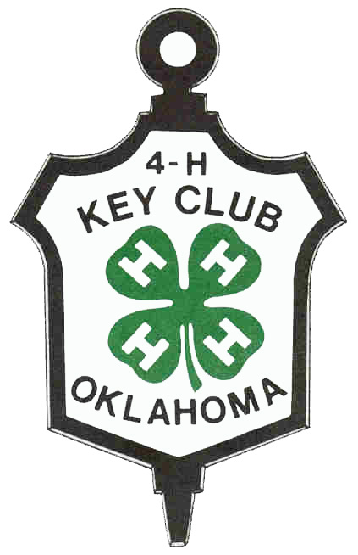

OKLAHOMA 4-H KEY AWARD PROGRAM

Established 1950

Oklahoma State University, as an equal opportunity employer, complies with all applicable federal and state laws regarding non-discrimination. Oklahoma State University is committed to a policy of equal opportunity for all individuals and does not discriminate based on race, religion, age, sex, color, national origin, marital status, disability or veteran status with regard to employment, educational programs and activities, and/or admissions.

Oklahoma 4-H Key Club: An Explanation
Oklahoma 4-H Key Club membership is an honor extended only to the top 4-H members. It is an honor that you must work hard for, but upon receiving the award, you and your Cooperative Extension staff will feel pride and satisfaction for a job well done.

History
Since 1950, the 4-H Key Club has recognized Oklahoma youth's accomplishments in the 4-H Program. The club seeks to honor 4-H members who possess leadership, loyalty, and a sense of responsibility to the entire 4-H Program.

Objectives
The objectives of this organization are:
1. To recognize the outstanding accomplishments of Oklahoma’s very top 4-H members.
2. To provide a common bond among former 4-H members.
3. To further develop 4-H work in Oklahoma.
The program is based on standards. Individuals meeting these standards are eligible to become members. Key Club is an honor society for 4-H members who have done outstanding work. Once 4-Hers become Key Club members, they accept the obligation to support the 4-H organization throughout their lives, both financially and with their time. Key Club members also strive to stay updated with Oklahoma 4-H and the Oklahoma 4-H Key Club.

Qualifications for Membership
The applicant:
1. Must be a 4-H member. Must show an ACTIVE status in the online 4-H enrollment program.
2. Must be in 9th, 10th, 11th, or 12th on September 1, on the year of application.
3. Must submit completed application form by the published state record book deadline.
4. Must accumulate the minimum number of points (400) on the application form.
5. Must be approved by the county Extension Educator.
6. Make at least one presentation about Key Club to a 4-H Group.
7. Must make at least one presentation to a non-4-H Group, such as non-4-H youth or adults, about the
4-H youth development program.

Awards
Applicants who qualify for Key Club will receive a Key Club certificate and key.

Membership Procedures
1. Key Club membership is awarded only to 4-H members who qualify based on the application.
2. Each county will designate an Extension Educator or staff member to verify the information in the application and submit the names of eligible members selected from the county to the state 4-H office.
3. There is no limit on the number of applicants from a county for a given year.
4. Two keys for each county will be provided – they must be ordered on the county medal order form. Counties desiring to present more than two awards will be responsible for purchasing the additional keys from the Oklahoma 4-H Office at Oklahoma State University.
5. Applicants will become official Key Club members contingent upon the Extension Educator adding the delegate's name to the Oklahoma 4-H Record Book Database by the published state record book deadline.
6. Each county Extension Educator will be responsible for:
- Distributing the application forms to the prospective members.
- Checking and approving application forms. (Forms do not get turned into the State Office)
- Adding the delegate's name to the Oklahoma 4-H Record Book Database by the published state record book deadline. (Educators: delegates should be added to the Key Club Award)

The following reports are required for membership in the Oklahoma 4-H Key Club.

PART I: Presentation
To be considered for 4-H Key Club membership, you must make two (2) 4-H presentations: one about the 4-H program and one about the Oklahoma 4-H Key Club. The presentation about the 4-H program must be to a non-4-H group; the presentation about the 4-H Key Club must be to a 4-H group. PowerPoint resources are available on the Oklahoma 4-H Website to assist in making these presentations.

PART II: Reports
After the presentations, the 4-H member must write two reports, one for each. The following information must be included at the top of the page for each report:
- Name of Group
- Contact Person
- Mailing Address
- Phone Number

Narrative:
The narrative portion of each report must be no more than 1 page long and be on one side of an 8 1/2 x 11 sheet of paper, using 1-inch margins on all sides. The report must be neat, and the information must be accurate and complete. Attach reports to your 4-H Key Club application. Items to be reported in each essay include:
- Name of program
- Date and location the program was presented
- Number of people in attendance
- What type of response did your program receive? Did sponsorship or awareness of the 4-H program increase in some way because of your presentation? Do you have other observations/comments?

Oklahoma 4-H Key Award Program

Application Form

County: |  |  |  | Local Club:
Name |  |  |  | Phone #
Complete Mailing Address |  |  |  | Name of Parents or Guardian:
 |  |  |  | Grade in School:
Number of Years in 4-H: |  |  |  | Total Number of Points earned:
Birthdate: (00/00/0000)

All items are optional, but 400 points must be earned for membership. Points are accumulated based on your total years of work in 4-H.

Activity | Number | Points per activity | Maximum points | Points Earned
- Submitted a Project Record Book or Advanced Project Record Book to the county for state competition  Number of years you entered a State Record Book |  | 10 | 50
- Submitted a county project report form to the county office  Number of years you entered a county report form or county record book. |  | 5 | 30
- Held a 4-H office, such as President, Vice-President, Secretary, Song Leader, Recreation Leader, Reporter, etc. at the local or county level, or served as a state 4-H Ambassador or a project-based ambassador program (Healthy Living Ambassador, Shooting Sports Ambassador, STEM Innovator)  Include all offices for all years.  - Local office  - County office  - District office  - State Leadership Council  - State 4-H Ambassador  - Project-Based Ambassador: list: | # of years | 5  5  10  10  10  10 | 20  20  20  20  20  20
- Gave an original 4-H Presentation before a regularly scheduled meeting to a Civic Group (such as Lions, Kiwanis, HCE, Business & Professional Women, Farm Bureau, American Farmers and Ranchers, PTA, or other non-4-H group) on the local or county level. At least one presentation and a follow-up report are required for the award.  List group, name, contact person, and date of presentation |  | 25 | 50
- Gave a presentation on the 4-H Key Club to a 4-H Club. List the name of the club, the leader’s name, and the date presented. Include the report. This is required to become a Key Club Member. |  | 25 | 25
- Gave an original presentation before a 4-H group other than your own local club. List the name of the club, the name of the club leader, and the date. Include the report. |  | 5 | 50
- Leadership activities (one experience = 20 points)  - Instructed 4-H members or others in one or more workshops at 4-H camp, club meeting, or other meetings  Name of Activity/Workshop  Place presented and date  - Assisted 4-H members with record books at one or more meetings  Name of member(s) and Date  - Served as an active member of one or more local or county committees (i.e., recreation, cleanup, etc.)  Name of committee  - Trained 4-H members in demonstrations, judging, and/or project work.  Name of Member(s) & Date  - Trained non-4-H members in a project area  Name of person & project area |  | 20  20  20  20  20 | 20  20  20  20  20
- Served as a teen leader- planning and conducting programming for a 4-H project group that meets six (6) or more times yearly.  Name of group and year(s) led. |  | 50 | 50
- Organized community programs that developed citizenship in the community, county, or state, such as Kids Helping Kids, Community Beautification, and Community Projects Associated with 4-H Month. (Attach additional page to list work, if necessary) Name of Group & contact |  | 5 | 50
- Entered at least six different county events, such as the county fair, project show, fashion revue, Share the Fun, Judging events, Public Speaking Contests, etc.  List events |  | 5 | 50
- Attended a 4-H Camp, day camp, or conference, including district conference or 4-H Round-up. Please list. |  | 5 | 50
- Set up an educational display at a District or State Event  Name of display & event |  | 5 | 15
- Made a radio or television appearance promoting 4-H.  Month/Year/Station |  | 10 | 40
- 2 points for each new 4-H Club member recruited  List names of new 4-H members: |  | 2 | 20
- Delegate to Citizenship Washington Focus – year attended |  | 20 | 20
- Delegate to National 4-H Congress – year attended |  | 20 | 20
- Delegate National 4-H Conference – year attended |  | 20 | 20
- Delegate to 4-H On the Road to Leadership Conference – year attended |  | 20 | 20
- Delegate to other out-of-state 4-H Educational Conference  Name of conference and year attended |  | 20 | 20
- Member of the judging team representing Oklahoma  Name of Judging Event & year |  | 20 | 20
Total Points Available |  |  | 820
Total Points Earned (must be 400 or more)

Member Statement
I have rated myself, and personally filled out this report, and have earned I have attached my report about my two 4-H presentations for points based on my 4-H club work.

Approval
We have reviewed this report and checked the points the member earned and believe it to be correct.

